Unit 7 Living with disease
Integrating Skills:
Diagnosed with cancer: The day my life ended and began!
教学目标：
知识目标：1.培养学生的阅读技巧。
2.理解课文中的长句及一些词汇。
3.如何写简短的记叙文。
能力目标：重点培养学生的阅读能力，其次培养说的能力、写的能力及综合运用英语的能力。
德育目标：使学生从患病作者同疾病作斗争中学习他不畏困难的精神；及鼓励学生们也要在学习中、生活中遇到困难时不放弃，并勇敢面对，积极进取，走向成功。
教学方法：通过展示图片、设置问题、和多种练习激发学生的学习兴趣。
教学重点: 理解课文，并了解记叙文的写作方法。
教学过程：
Step 1. Leading-in
T: These days we are talking about people living with disease. Xiaohua is one of millions of children in the world living and dying with AIDs. Can you say a few sentences about her?
T: You may discuss in your group for a short time.
S1: I think Xiao Hua is great. She herself is in trouble, but she tried her best to help other people.
S2: I respect her. When she faces difficulty, she doesn’t give up. Perhaps her life is short, but there is no reason why it isn't beautiful.
…
T: Very good!
T: Just imagine if you were diagnosed with a deadly disease, how would you feel and what would you do?
S3: I would spend most time staying with my family and friends.
S4: I would feel sad, but I would never give up.
…
T: Today we’ll read a passage to know more .
Step 2. Pre-reading
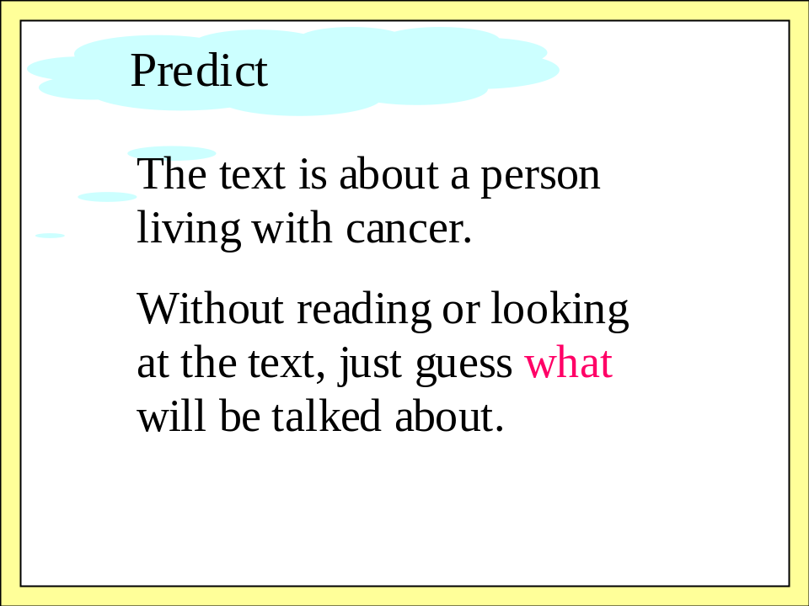
S5: I guess it’s about a person living with an incurable disease and he struggles against the disease.
T: You’re very clever. You’re quite right.
Step 3. Fast-reading
T: I’ll give you only one minute, and you try to match the paragraph and the main idea of each paragraph.
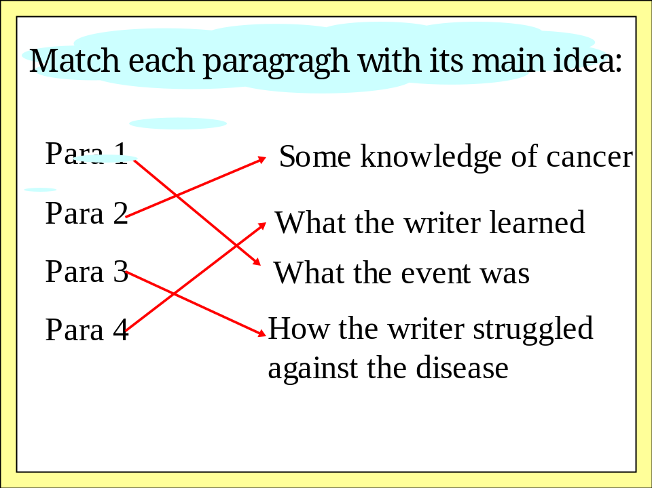
Step 4: Careful-reading
T: Let’s read the passage again more carefully to get more details. We’ll read the text one paragraph by one paragraph. First, Paragraph 1, let’s make it clear what was the event. Two questions for you.
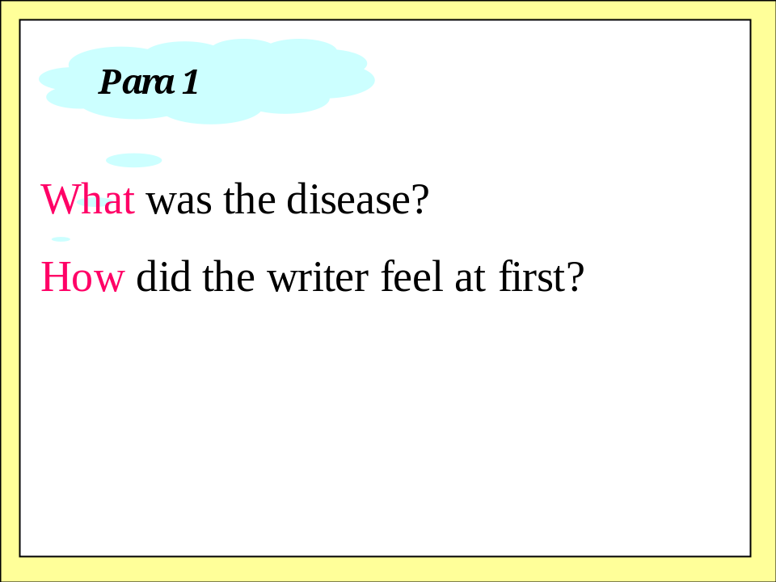
T: In paragraph 2 we learn some knowledge of cancer. We learn that cancer is not that terrible.
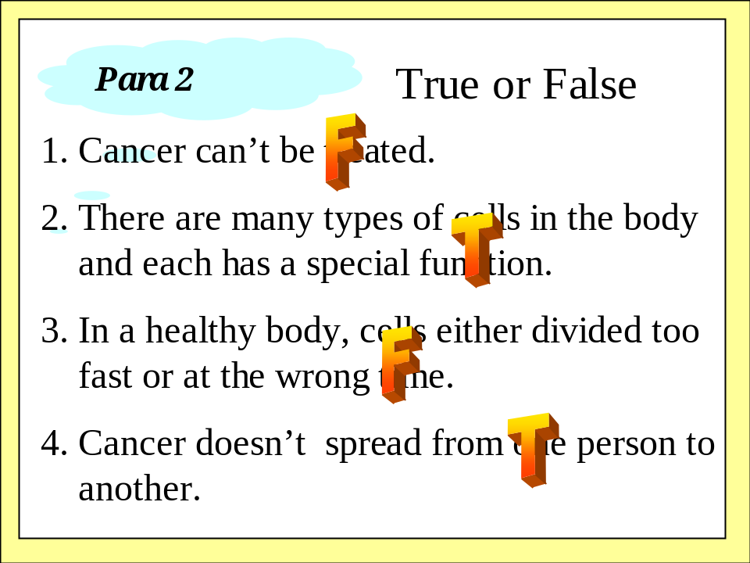
T: When we are in trouble or meet with difficulty, who always help us?
Ss: Our family, our friends, our teachers, and so on.
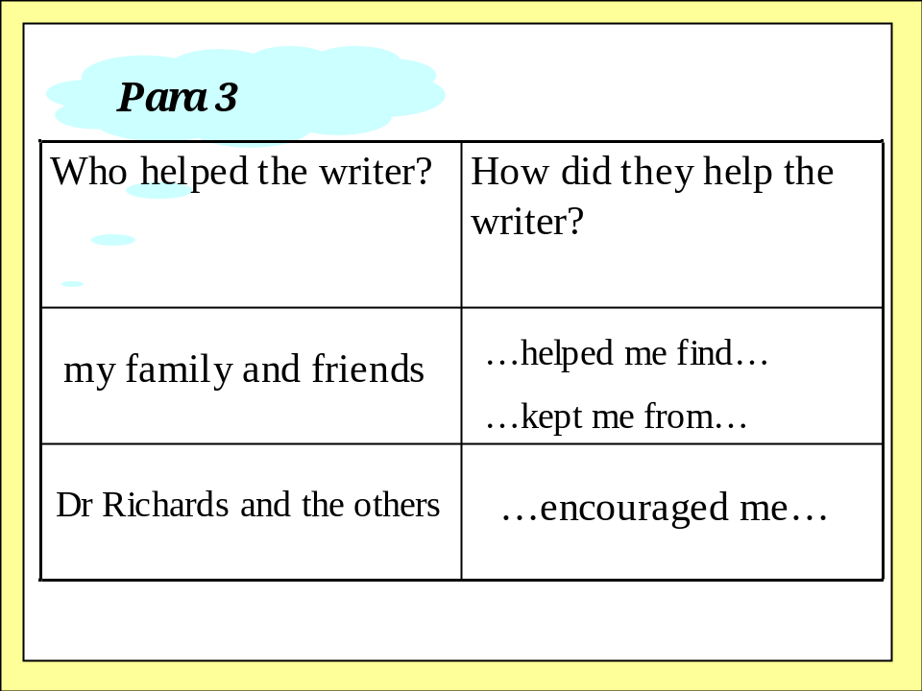
T: Sometimes we come to the lows, I don’t think it is bad. The lows often make us think, and we can learn something from them.
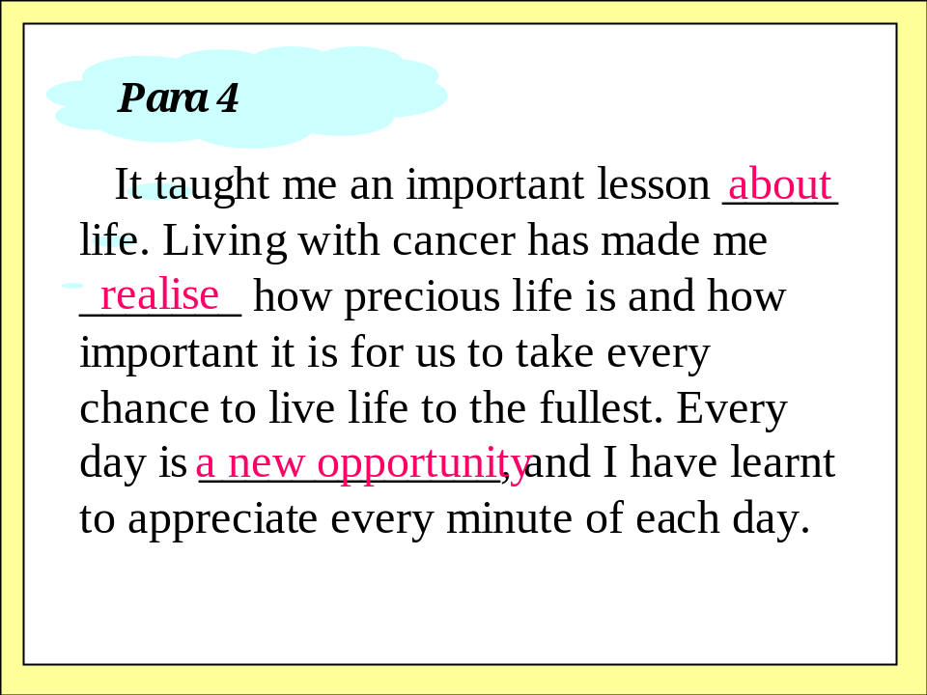
T: Now I’ll tell you two more stories. And I’m sure you’ll be moved. I admire them very much. They are our idols.
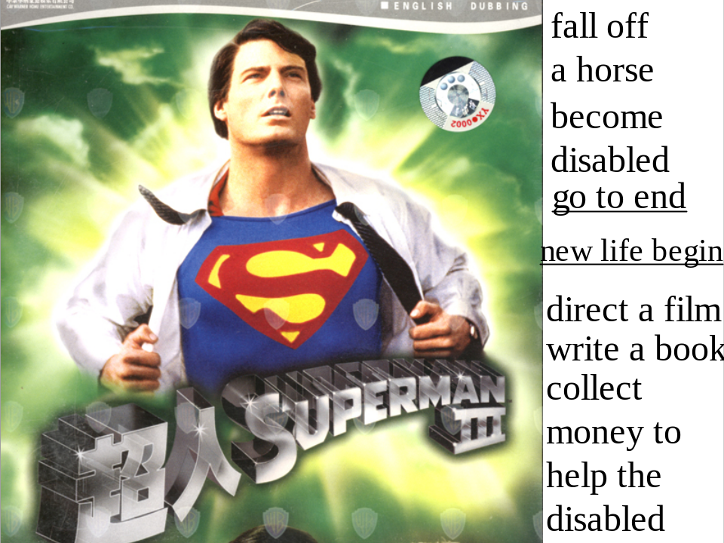
T: As you see, he is the superman. He is the symbol of power. He can do anything to help people. But something bad happened to the actor one day when he fell off a horse. He became disabled. And at first, he thought his life went to end. But he didn’t give up. Later, he directed a film, wrote a book and collected money to help the disabled. Though he was weak in body, but strong in mind.

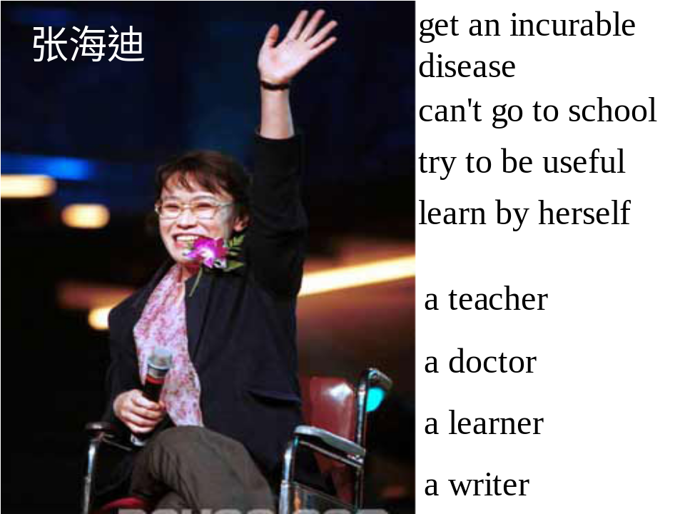
T: From the wheelchair we can see she is disabled. She got an incurable disease at a very young age. She couldn’t go to school at all. But she tried to be useful. She learned by herself. Later, she becomes a teacher, a doctor, a learner and a writer. From the smiling face, we’re sure she is happy.
Step 5. Discussion
T: What can we learn from the text?
T: Do you have any trouble in your life?
S6: Little time to sleep.
S7: I can’t play basketball well.
S8: Parents’ meeting is coming.
…
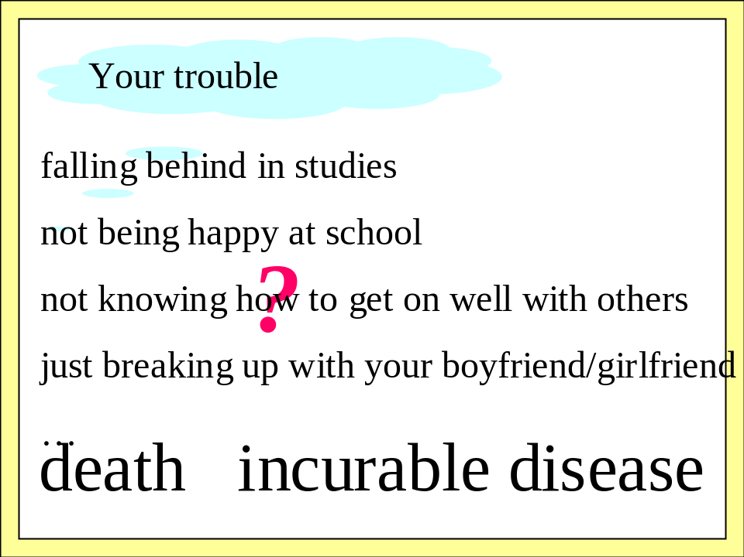
T: Every now and then we have trouble, but they are much smaller than death or incurable diseases.
T: Facing the trouble, what’s the right attitude?
S9: I often ask my friends for advice and suggestions.
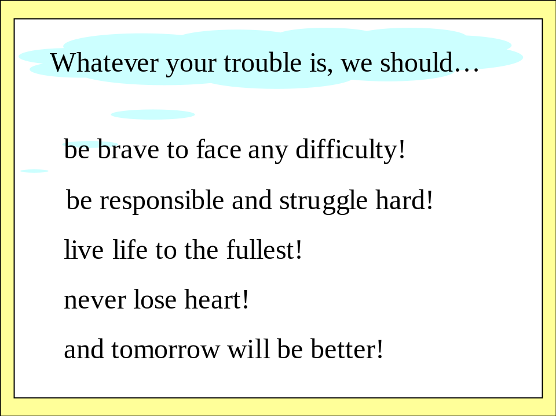
T: Good! You’ve learned a lot from the text. In one word: Never give up! Be brave to face any difficulty!
Step 6. Competition
T: Next, I’ll give you some phrases, and you give me the Chinese meaning the moment you catch them. I’ll give them one by one. Let’s see who is the fastest? Are you ready?
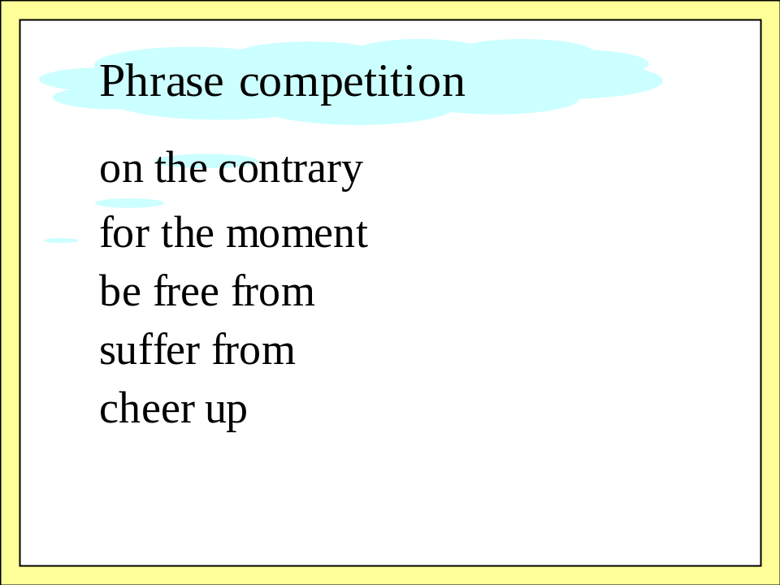
Step 7. Grammar
T: We learn about the Subjunctive Mood. Let’s have a try.
1. (2002 上海) It is hard for me to imagine what I would be doing today if I _______ in love, at the age of seven, with the Melinda Cox Library in my hometown.
- wouldn’t have fallen B. had not fallen
C. should fall D. were to fall
2. Had the boy worked harder, he _______ the exams.
- must have got through
- could get through
- ought to get through
- would have got through
T: The answers are B and D. You may think they are hard. Don’t be worried. From now on you’ll have more chances to improve.
Step 8. Writing
T: Writing is an important skill for students.
T: Before you write this kind of composition, we’ll share the answers of the following questions.
What are the best times ( the highs) or the worst times ( the lows)?
Why is it important in your life?
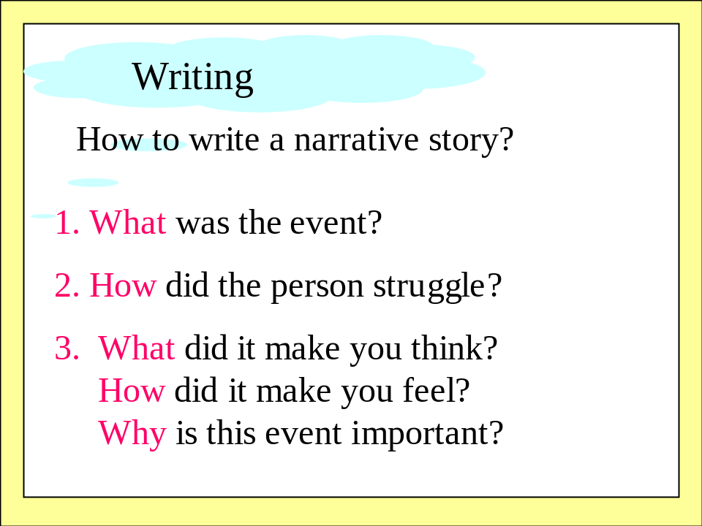
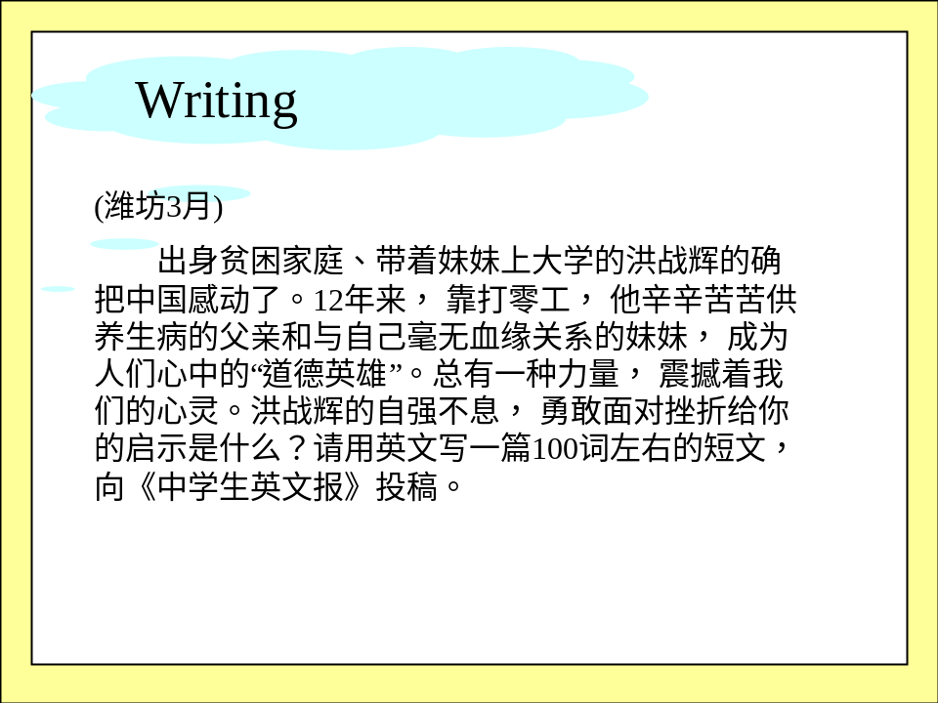
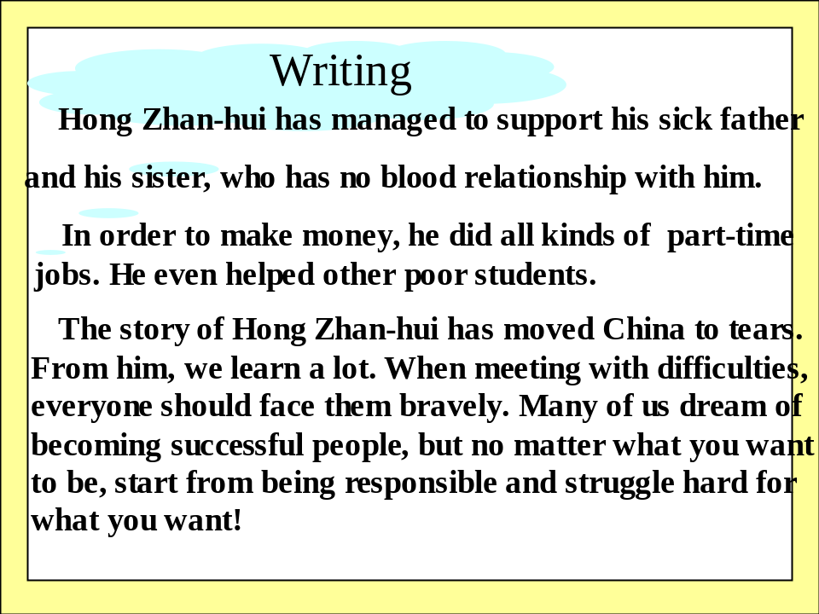
Step 9. Homework
Writing: (100 word) What were some points in your life when you made a big change or learnt an important lesson?

